  - Downloading Quartus
- Go to the Intel FPGA Download Page
  - https://www.intel.com/content/www/us/en/software-kit/849770/intel-quartus-prime-lite-edition-design-software-version-24-1-for-windows.html
- Choose the Correct Version
  - Select version 24.1(Latest) from the drop-down menu.
  - Please verify that you have selected the following parameters. FPGA Development < Quartus Prime Lite < 24.1 (Latest) < Windows
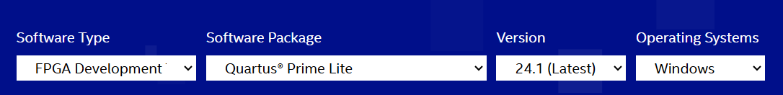
  - Once satisfied, press the download button below and accept the legal disclaimer when prompted.
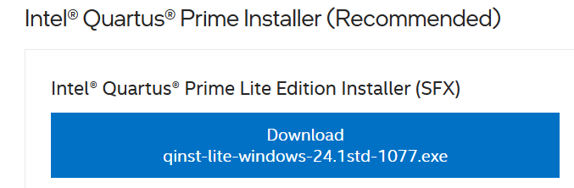
  - Your zip file will now be downloaded, open the folder to begin the setup process. If your file has not downloaded, please click the link to redownload the zip folder.
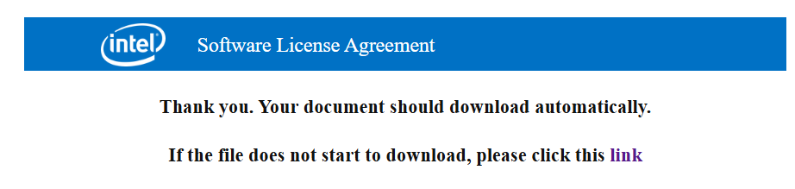
  - Check off the following components.
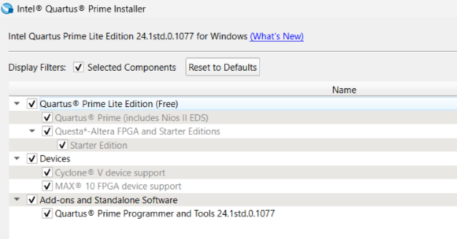
  - Select the Intel License Agreement and click Download and Install. This installation will take a while to complete. Please be patient.
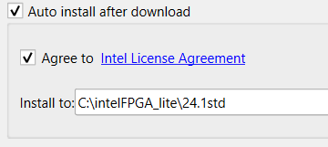
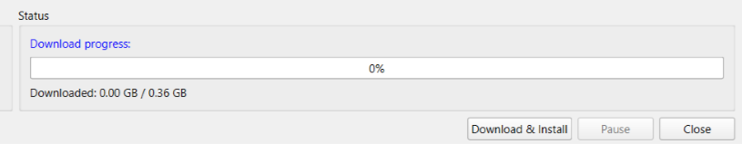
  - Once the download and installation are complete, close the window and open up Quartus. You should see a screen that looks like this:
